Date: | Responsible for experiment, name and telephone: |  |  |  |  |  |  |  | Expt nr/ lab.book page
Reaction formula (structures, conditions, approx. reaction time, reagents to be included in list below)

Preventive measures:

Action in case of incident during reaction:

Planned workup and purification (solvents etc to be included in list below):

Action in case of incident during workup and purification:

Waste disposal:

 |  | Safety classification (mark with cross for all compounds to be used).
Reagents, solvents, amounts |  | 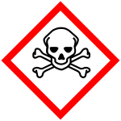  Toxic | 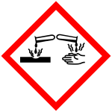  Corrosive | 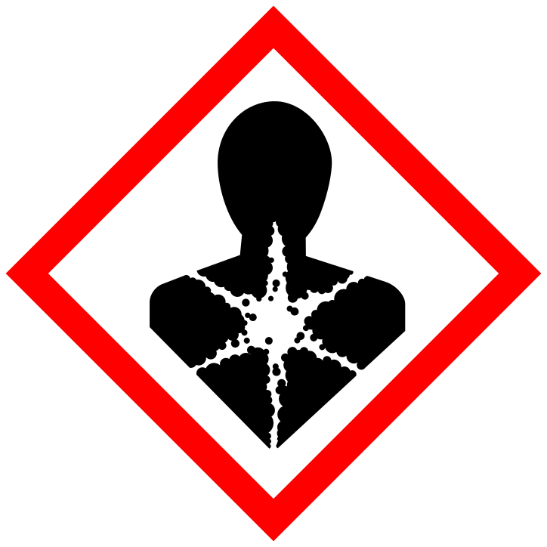  Health hazard | 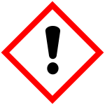  Harmful | 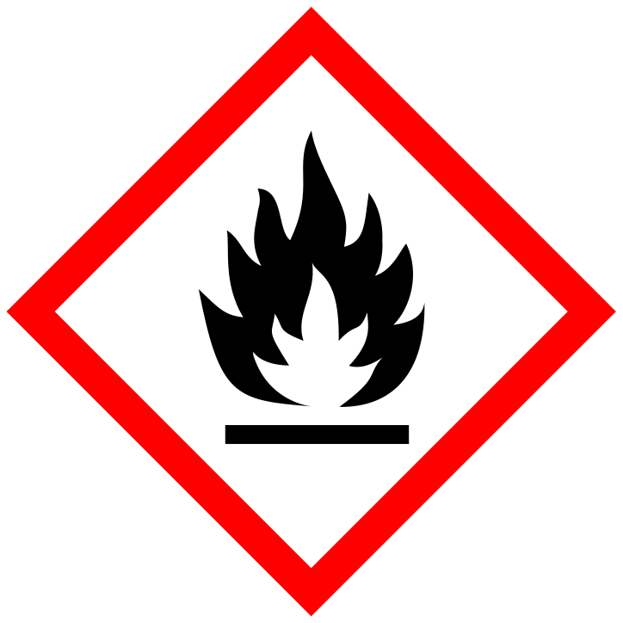  Flamm-able | 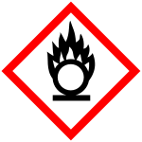  Oxidising | 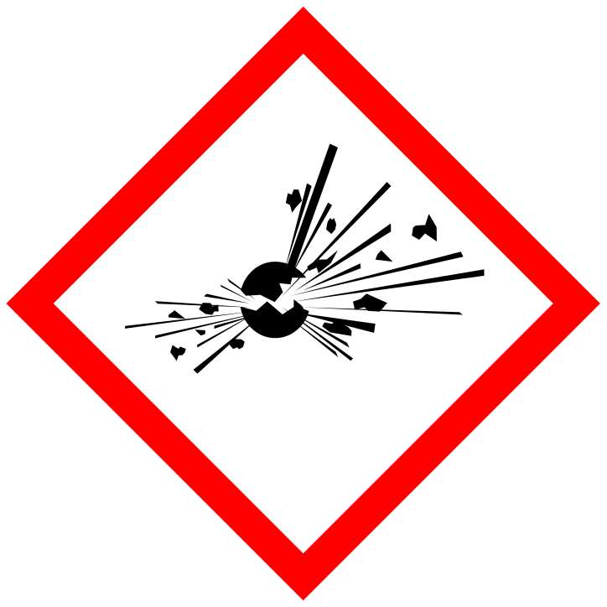  Explosive |  | 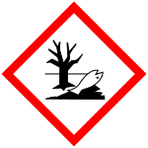  Environ-mental hazard | other information
Overall risk of experiment (reaction+workup+waste disposal) |  | Low |  | Moderate |  | High* |  | Very high*
* Signature of supervisor, associate supervisor or head of department (prefekt) required in this field for each experiment.
All experiments with high toxicity compounds at any stage fall in the high or very high category. All experiments involving explosives at any stage fall in the very high risk category. NOTE: also other experiments might on the overall rating (including the risk associated with the scale of the reaction) fall into these categories!

Date, signature, name

